Dalton Murray

Chapter 10 Testing

CSS Validation –

I have both visually checked the CSS code for any errors on each web page with varying resolutions and browsers and checked it physically by looking at the CSS code itself. I have also ran the CSS code through two different validators, as confirmed by the following screenshots from W3Schools (<https://validator.w3.org/nu/#textarea>) and Jigsaw (<https://jigsaw.w3.org/css-validator/validator>) owned by W3Schools but does the same thing to confirm.

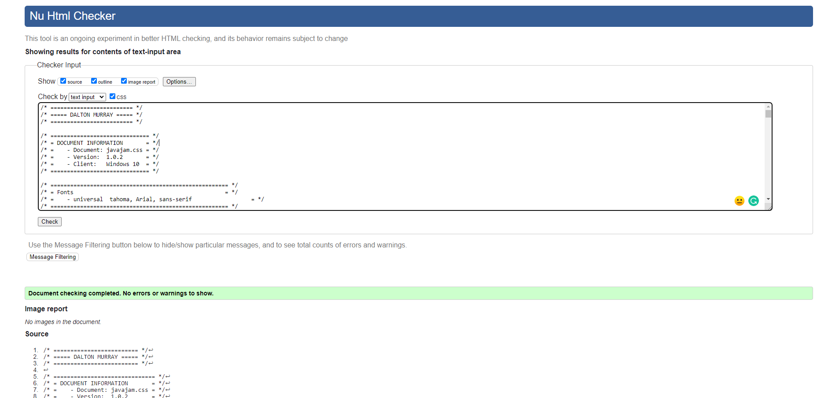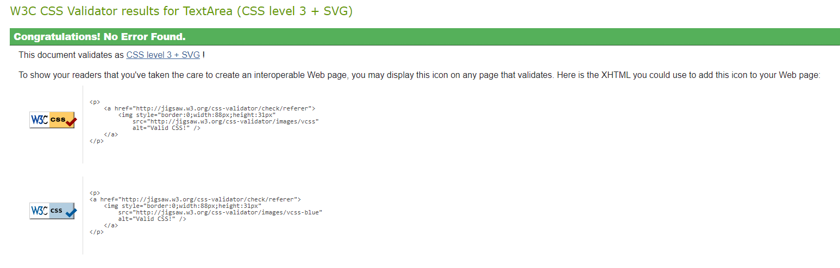

HTML Validation –

I have also both visually checked the HTML code for any errors on each web page, with varying resolutions, and browsers. I have checked both to ensure that it looks and works how it was intended to work. I have ran all the HTML code through W3Schools html validator (<https://validator.w3.org/nu/#l37c94>) as well as Freeformatter (<https://www.freeformatter.com/html-validator.html>).

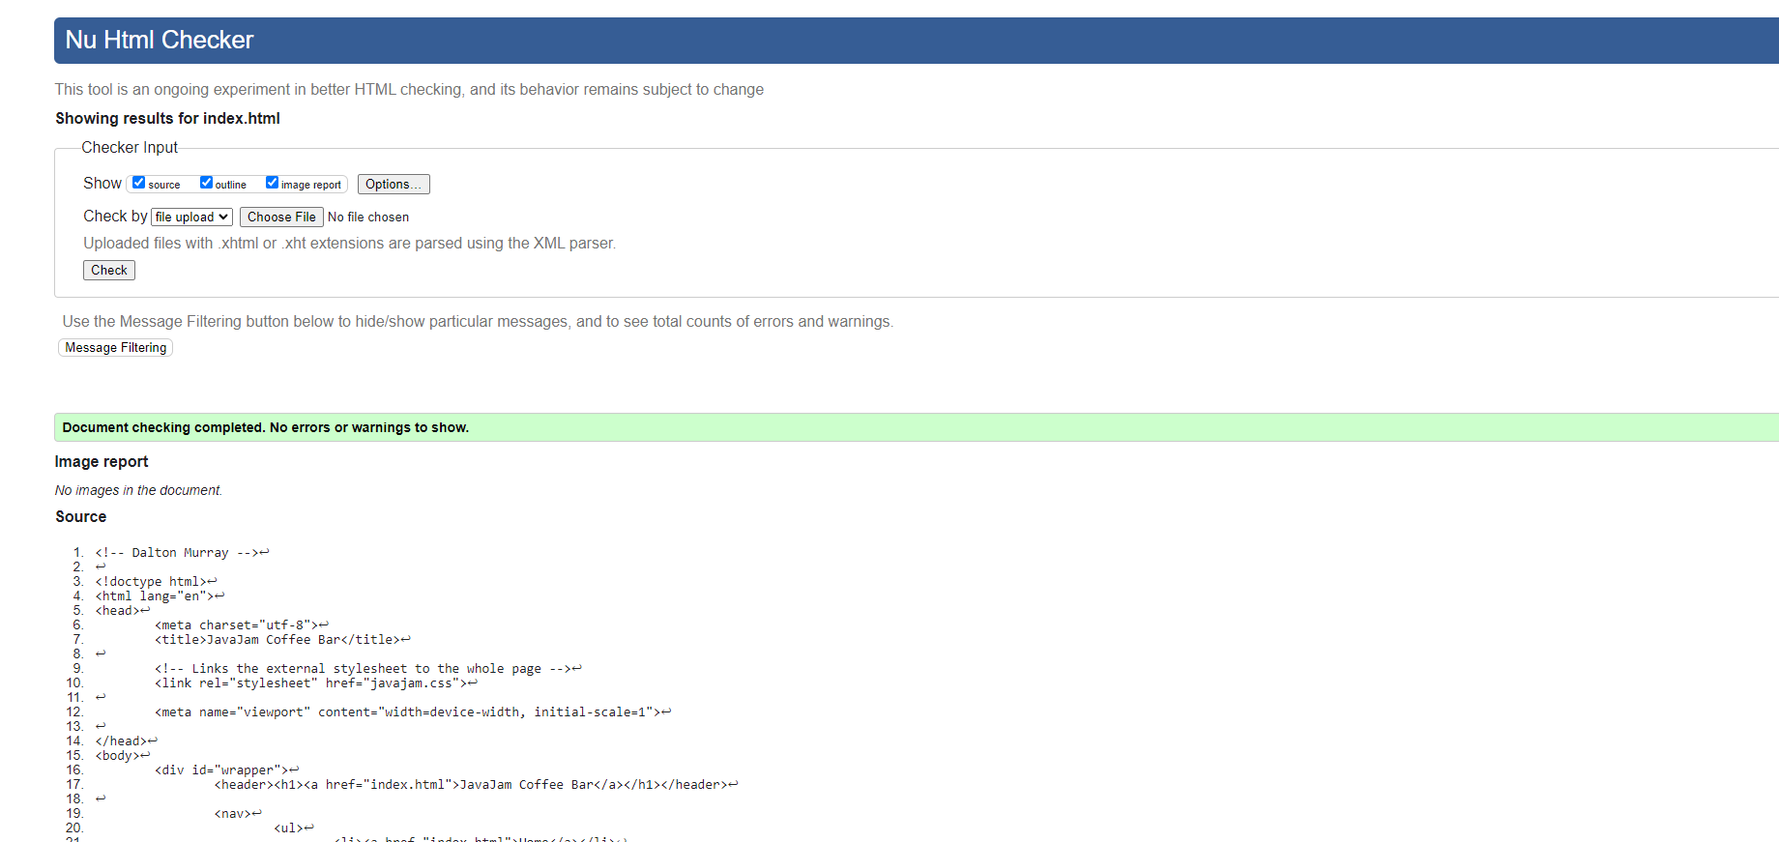

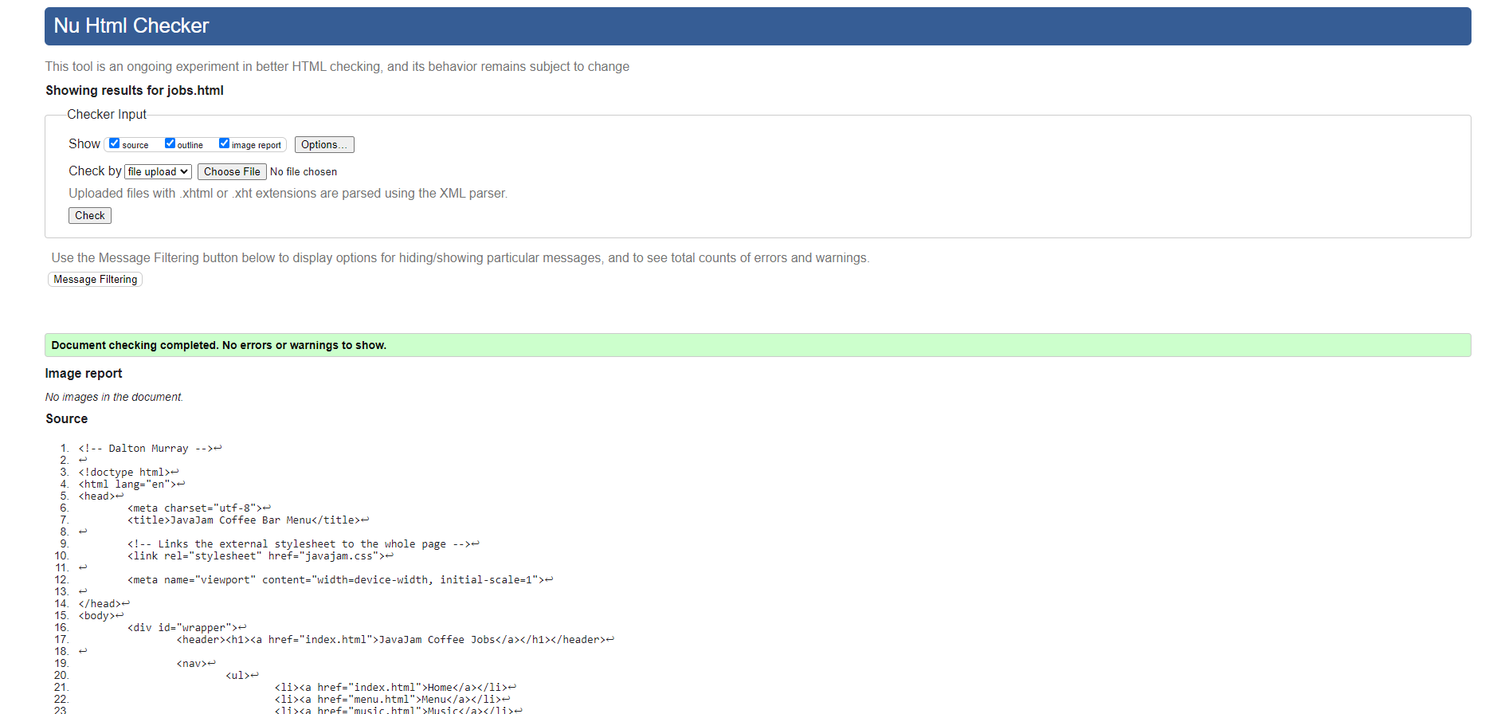

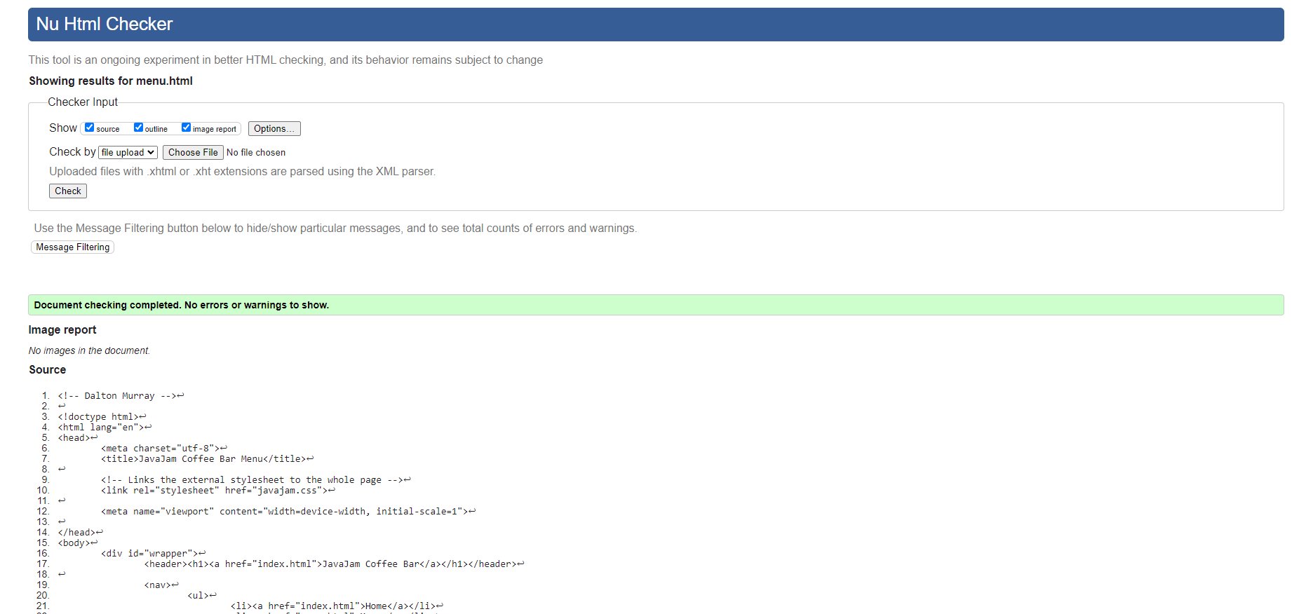

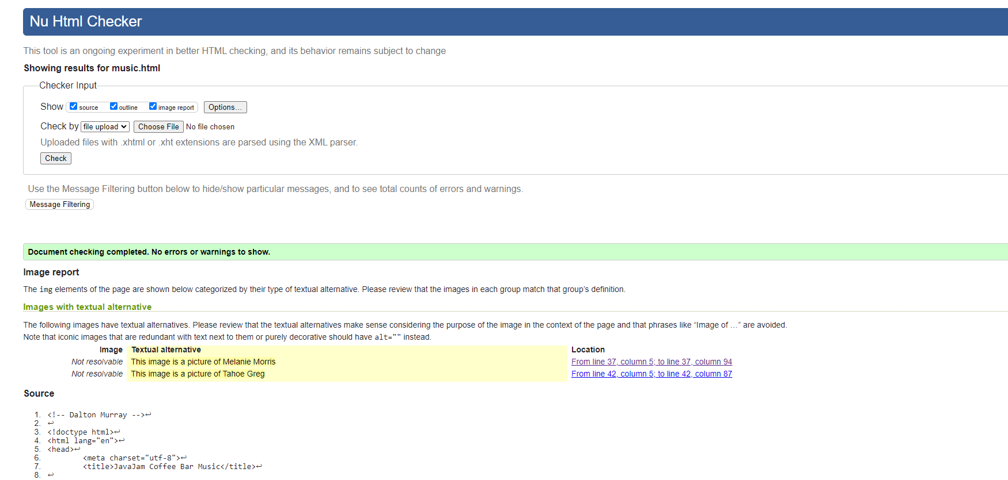

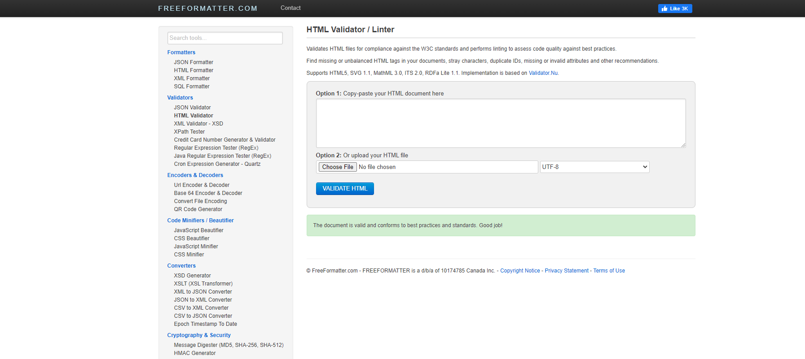

Accessibility Testing –

During my accessibility testing period, I ensured that all images had alternative available text, as well as I ensured that I followed all standard accessibility practices where possible. Unfortunately, due to the strict guidelines/requirements of the book, some things I wouldn’t be able to change in order to fully establish accessibility.

Testing/Improvements -

While I thoroughly tested the website to make sure that everything works, I have brought up some suggested improvements. Unfortunately, because I am supposed to follow all the things that are in the book, I am limited in what I can change if I am supposed to make sure it looks like how the book shows it and code it similarly.

* One of the improvements which I have made are changing how some of the images look to appear better in different browsers with different resolutions
* The website is very simple and easy to navigate, however, there isn’t much actual content
* Although there are required media selectors (600px and 1024 px) I would recommend still making it fully responsive so it can scale/work/look good in every resolution such as wide screen monitors
* The menu off to the side looks quite empty, this could be due to a lack of content or due to how we are told to make it look
* I have also made some minor changes while progressing through the chapters so that it looks more professional in coding